Build , new_Build, powerShell

# Zadani : Oprava build batek s pouzitim Msbuildu

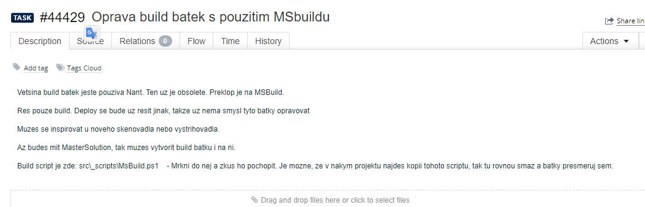

# Prikazy prikazoveho radku cmd

[**https://ss64.com/nt/**](https://ss64.com/nt/)

# Stary nanti build:

call ..\..\..\tools\NAnt\NAnt.exe -buildfile:_build/project.build.xml -l:buildlog.txt %1

# Spravny novy powerShell build

--call ..\..\restore_nuget_packages.bat

powershell -ExecutionPolicy Unrestricted "..\..\_scripts\MsBuild.ps1" -RepositoryDir ..\..\..\ -RestoreNuget $false -ModuleDir "." -Solutions "MIR.PrintStorage.Scanning2.sln" -NoTests $true

pause

**Horni volani restoru nugetu je zakomentovane. Je uvedena cesta k MSBuildu, ktery je v _scripts\MSBuild.ps1 . Sem budou ukazovat vsechny batky. Momentalne maji casto svuj MsBuild rovnou ve svoji slozce.**

# Admin:

powershell -ExecutionPolicy Unrestricted "%~dp0MsBuild.ps1" -RestoreNuget $true -ModuleDir "." -Solutions "%~dp0MIR.Media.Admin.sln" -NoTests $false

pause

# Admin new :

powershell -ExecutionPolicy Unrestricted "..\..\_scripts\MsBuild.ps1" -RepositoryDir ..\..\..\ -RestoreNuget $true -ModuleDir "." -Solutions "MIR.Media.Admin.sln" -NoTests $false

# Zakomentovani probiha jako u SQLManagment Studia dvemi pomlckami:

--call ..\..\restore_nuget_packages.bat

# Call

[CALL](https://ss64.com/nt/call.html) Call one batch program from another•

# Volani buildu subrepozitare:

call "..\..\..\libsrc\PricingHg\src\new-build.bat"

## Admin

--call ..\..\restore_nuget_packages.bat

powershell -ExecutionPolicy Unrestricted "..\..\_scripts\MsBuild.ps1" -RepositoryDir ..\..\..\ -RestoreNuget $false -ModuleDir "." -Solutions "MIR.Media.Admin.sln" -NoTests $false

pause

**Vysledek:**

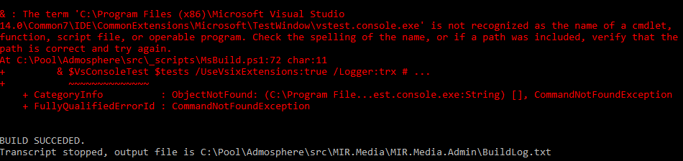

## Scripty MsBuild.ps1 totiz nejsou stejne:

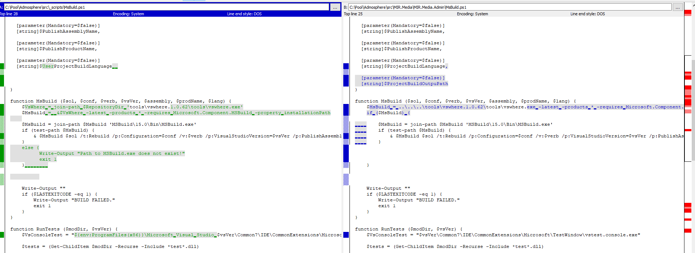

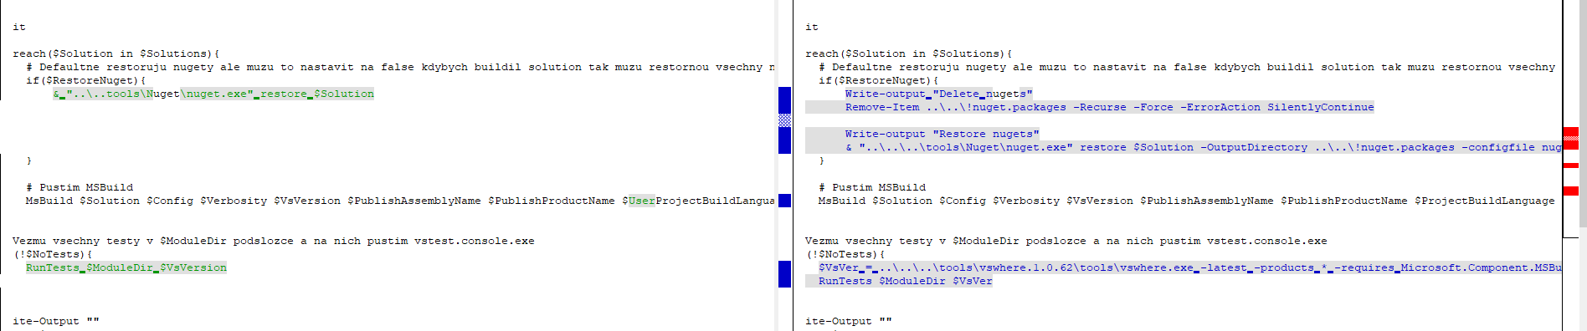

**Proto ho ma Admin ve sve slozce a vola ho takto:**

powershell -ExecutionPolicy Unrestricted "%~dp0MsBuild.ps1" -RestoreNuget $true -ModuleDir "." -Solutions "%~dp0MIR.Media.Admin.sln" -NoTests $false

pause

* **Admin** powerShell, MsBuild ve vlastni slozce
* **Approving** powerShell, MsBuild ve vlastni slozce
* **Catching** powerShell, MsBuild ve vlastni slozce
* **Changing2**  ma novou batku stejnou jako skenovadlo
* **Coding** powerShell, MsBuild ve vlastni slozce, navic ma zakomentovany build subrepozitare PricingHg
* **Changing2**
* **Cutting2** ma novou batku jako skenovadlo

**Framework** powerShell, MsBuild ve vlastni slozce, navic ma zakomentovany build subrepozitare PricingHg

**Importing2** powerShell, MsBuild ve vlastni slozce

**Norming** to same

**Common2**

**Export** call ..\..\tools\NAnt\NAnt.exe -buildfile:_build/project.build.xml -l:buildlog.txt %1

ma rozbite reference

**Import**

**Matching**

**Media**

**Pricing**

* **PrintStorage**

**Schedule**

**SimLog**

**TvLog.Generator**

**Spravny MsBuild je ten ktery nema teckovane oddelene urovne:**

**$MsBuild = ..\..\tools\vswhere.1. = spatne – nesmi tam byt ..\..\**

function MsBuild ($sol, $conf, $verb, $vsVer, $assembly, $prodName, $lang) {

$VsWhere = join-path $RepositoryDir 'tools\vswhere.1.0.62\tools\vswhere.exe'

$MsBuild = &$VsWhere -latest -products * -requires Microsoft.Component.MSBuild -property installationPath

$MsBuild = join-path $MsBuild 'MSBuild\15.0\Bin\MSBuild.exe'

**Mame dva druhy MsBuildu**

vola se takto: Pocet urovni je dany poctem urovni od urovne kde je _scripts. Takze jsem na urovni _scripts, do skenovadla jdu o dve urovne (dva doubleClicky)

**Pricing:**

--call ..\..\restore_nuget_packages.bat

powershell -ExecutionPolicy Unrestricted "..\_scripts\MsBuild.ps1" -RepositoryDir ..\..\ -RestoreNuget $false -ModuleDir "." -Solutions "MIR.Pricing.sln" -NoTests $true

pause

**Norming**:

--call ..\..\restore_nuget_packages.bat

powershell -ExecutionPolicy Unrestricted "..\..\_scripts\MsBuild.ps1" -RepositoryDir ..\..\..\ -RestoreNuget $false -ModuleDir "." -Solutions "MIR.Media.Norming.sln" -NoTests $true

pause

**Spravnou batku si davam na y:\new-build spravna batka a MsBuild**

# Aplikace pro ktere jsem udelal NoTestBatku

Normovadlo – Filip

Admin

Approving

Catching

Changing2

Coding

Cutting2

Framework – pada build

Importing2

Common2

Export

Import2

Matching

Pricing

Scanning

Shedule

SimLog

TvLogGenerator